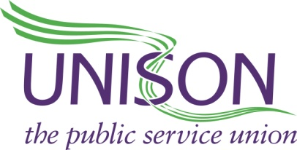

PAY CLAIM FOR
SUBMITTED BY UNISON AND UCU TO SANDWELL COLLEGE OF FHE

- INTRODUCTION
In accordance with UCU’s current pay agreement with Sandwell College we are presenting the heads of claim for the next pay round ahead of the expiry of the current one.
On this occasion the pay claim is submitted jointly by UNISON and UCU on behalf of staff working at Sandwell College.
The claim is set at a level that we believe recognises the following key points:
- Substantial increases in the cost of living over recent years have significantly reduced the value of staff wages; furthermore the rise in prices facing workers has been running at a 40-year high and although the rate of inflation appears to be slowing the price rises that have already occurred are likely to be permanent;
- Appropriate reward is needed to attract, retain and sustain the morale and productivity of staff in their crucial role of delivering high quality services;
- The nationally recognised Living Wage rate has become a benchmark for the minimum level of decent pay across the UK and is now paid by large sections of the public services and many major private companies. We believe that nobody should be paid less than the Living Wage.
- There has been no increase in the college mileage allowances for several years despite the increasing cost of fuel and car maintenance/insurance/upkeep.

2. HEADS OF CLAIM FOR 2024/2025
We are seeking:
2.1 A consolidated 10% increase on all pay spine points on the pay scale for the academic year 2024/25 where achievable, with a view to completing by the pay review date of 1 August 2024 in time for the August pay roll run.
2.2 If negotiations continue beyond August, then any agreement to be backdated to 1 August 2024.
2.3 If the AOC pay recommendation exceeds the local offer, then the local offer will be increased to match.
2.4 Staff on a fixed term contracts or who have been hourly paid for 3 years or more to be placed on permanent contracts.
2.5 An increase in mileage allowance to 55p per mile in line with other public
bodies e.g. Sandwell Council.
2.6 A commitment to begin joint formal pay negotiations, for next year, to begin
March 2025.

