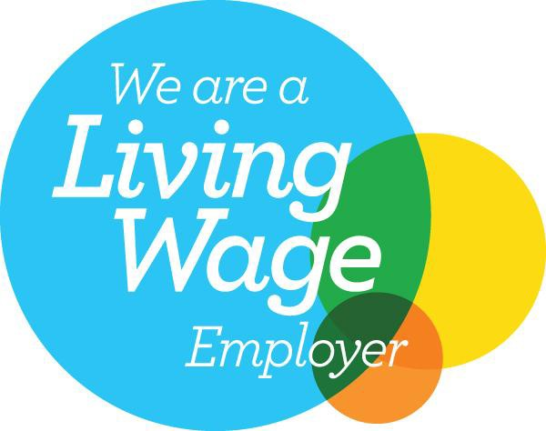
Sandwell General Branch
West Bromwich Town Hall
Lodge Road
West Bromwich
West Midlands
B70 8DY
Tel: (0121) 569 5996
Email: sandwellunison@btconnect.com
Website: www.sandwellunison.co.uk
12 September 2022

Proposed Increases to Parking Charges

To Cabinet Members,

Firstly, I need to register UNISON’s disappointment that the trade unions needed to request consultation on the proposed changes, otherwise we would not receive any. These proposals do affect our members and therefore it is disappointing that Officers initially ignored the trade unions from any consultation process.

The proposed increase in parking charges is of extreme concern to our members/your staff, particularly given the cost-of-living crisis we are all currently experiencing.

The proposed increase in annual car parking tickets for car parks outside of West Bromwich, from £240 to £400 next year, and then to £600 by 2027, will hit our members hard.

It also has a disproportionate effect on staff required to be physically present to undertake their duties, or where their home situation is not suitable for home working.

The rate of increase at 67% for 2023 and a staggering 150% increase by 2027 is an unjustifiable increase and we strongly urge you to reconsider the level of the proposed increases.

In expressing our shock for the proposed increases for car parks outside West Bromwich, the proposed increases for car parks in West Bromwich are simply unbelievable.

The proposed increase in fees for annual parking passes from £240 to £800 in 2023 represents a 333% increase! By 2027, when they reach an unbelievable £1200, it equates to a 500% increase.

These eye watering proposals will simply result in staff not paying to park as they are unaffordable, therefore you will lose revenue from parking, not gain it.

Furthermore, when the £240 parking fee was introduced across the Borough it was done so with the view of equalising the cost of parking across the Borough so that staff in West Bromwich were not unfairly treated. These proposals bring back this unequalness.

The proposed increases in annual passes percentage wise is proportionately far greater than the increase in daily fees and therefore penalises those staff that must attend their workplace every day.

The Council House remains half empty and such proposed increases in parking can only empty it further, when the residents of Sandwell want Council services to return to being as responsive as pre-pandemic.

UNISON urges Sandwell’s Councillors to:-
- Reconsider the rate of increase for annual passes.
- Reconsider introducing even higher charges for West Bromwich.
- Consider a significant discount for your staff if these go ahead.
- Encourage the use of electric vehicles across the Borough by making them free to park, thereby promoting the aspirations of Sandwell’s green agenda.

We look forward to a reasonable response.

Tony Barnsley
Tony Barnsley
Branch Secretary
Sandwell General UNISON Branch

